**MAP:**

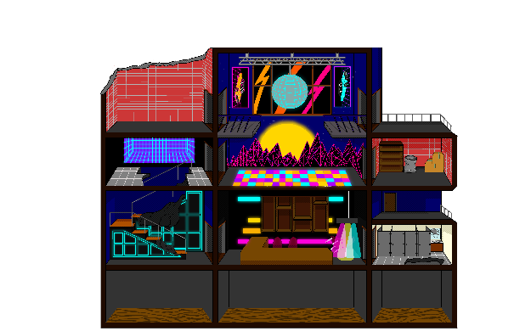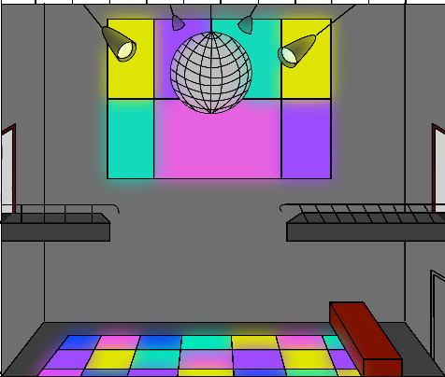The idea for the map of the game was to have a building with multiple rooms and floors to allow for a large movement space. The original concept was a mansion with multiple rooms of roughly the same size. We realized the uniformity of the room sizes didn’t fit our game and neither did the building style. We then came up with a club building which allowed us to incorporate the colors that fit our theme as well as differ the room sizes. In the first draft the club appeared very empty with little detail and didn’t allow for free-flowing movement throughout the map as certain areas were impossible or hard to reach. Furthermore, it still didn’t give of the mood of the game we wanted to achieve. Draft 2 was better looking aesthetically but the rooms still had a lack of details in them as well as the entrances and holes need to be redesigned to finally allow for the free-flow movement that we wanted to achieve, as this problem caused the gameplay to be restrictive to only certain rooms and didn’t allow the character to get away from the enemies efficiently. Draft 3, the final draft, had the missing details added in and repositioned entrances and holes. The map certainly could be improved my adding in little details around the place that are not necessary for the gameplay but would look nice. Although some parts were intentionally left empty as we overlaid the vending machines as a separated image in Corona.

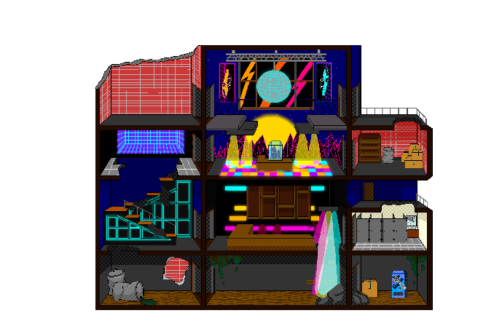

Implementing the map into Corona was done by Wiktoria. This was tricky as the map was much bigger than the screen display size and unfortunately Corona doesn’t have a built-in camera system. The initial idea was to create a skeleton of all the walls as a PNG and overlay that on top of the main image for the map, unfortunately it wasn’t realized that Corona accounts for all the empty space as a full object and not just the drawn-in walls in the image. This made the process of adding in the walls, floors, and object much more time consuming as each had to be placed individually. This also showed us other problems. As mentioned above Corona doesn’t have a camera system and our map was bigger than the size of the screen. To combat this, frame-based movement was added in to allow us to navigate the map, as well as physics-based movement to allow the walls to be moved. Working on just the walls visible in the starting point was easy, just fixing coordinate positions but it didn’t become apparent that making the walls static was not an option. This was done to prevent collisions but when moving the images of the walls in Corona the static of the image would stay in the same spot on the screen even if the image itself was moved which cause a lot of “ghost walls”. This was fixed by making them kinematic for the time being.

Another problem which occurred when using the frame-based movement and physics-based movement on the map and walls was moving throughout the y-axis. Since the map utilized the character’s movement code for the x-axis by determining whether A or D was pressed while for the y-axis movement the character had gravity and didn’t require any key to be pressed. A piece of code was written to check the character’s y-value on the screen and if it was below or above a certain point the map would adjust accordingly. This almost fixed every issue. The remaining issue was when the character fell but also change its x-axis, the speed of the fall would be slower than when falling straight down, which caused the floors to be at the wrong position relative to the actual map image. For the final change to fix everything, Alan had changed the map code to be in a table rather than physics- and frame-based movement (I don’t remember what u called the new map layout system Alan so can you add that in).

**ART and ANIMATION:**

The Art and Animation code for the character was done by Wiktoria. It relatively simple as it fit the movement system of the character allowing the correct image and animation sequence to be determined by which key was pressed as well as if no key was pressed, to pause the animation. The size of the character was also changed in the final version to accommodate the new map layout and allow for the more free-flowing style of movement throughout the map.

The Animation code for the zombies was a bit trickier unfortunately, as it didn’t work of off frame-based movement nor a pressed key. The problem with this was when the zombie moved left or right the frame update would make the animation code think that it was never moving as it was always technically at frame one and therefore would play the animation or rather play only the first frame which made it took like the animation wasn’t working correctly. The only time the animation worked was when a zombie got stuck by an object as its frame wasn’t updating and the animation then could run through the frames.

Another feature which unfortunately didn’t work was the gun held in hand. The gun in hand was meant to switch depending on the gun being used. The code for the current gun was updated to a global variable to allow it to determine which gun the character should be holding but there was a problem where the gun wouldn’t switch to the current gun.

**MOVEMENT:**

The movement of the character went through a few different changes before finally deciding which worked best for our game. At the beginning, frame-based movement was used for the character to move on the map. A few small issues were seen in that initial code such as when switching between A and D too quickly. The code wouldn’t realize the key was switched due to the phase of the key not changing; basically, the phase never got to change from pressed to not pressed to pressed which meant the code didn’t update to the corresponding key. This was fixed by adding in code determining independently from the movement code whether a certain key was pressed and would update its value to true or false.

This code was later change by Alan to a slightly different frame-based movement that allowed for acceleration of the character. Most of the code stayed the same expect for determining the speed of the character. This also helped when jumping as the character could jump greater distance when his acceleration was greater.